First we have to create an instance

We have to search ec2 => instances > intstance or launch instance

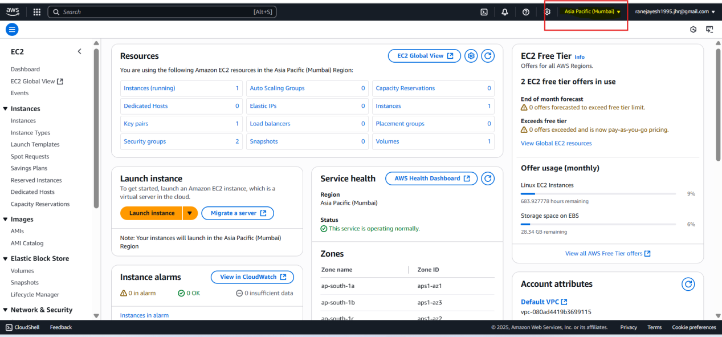

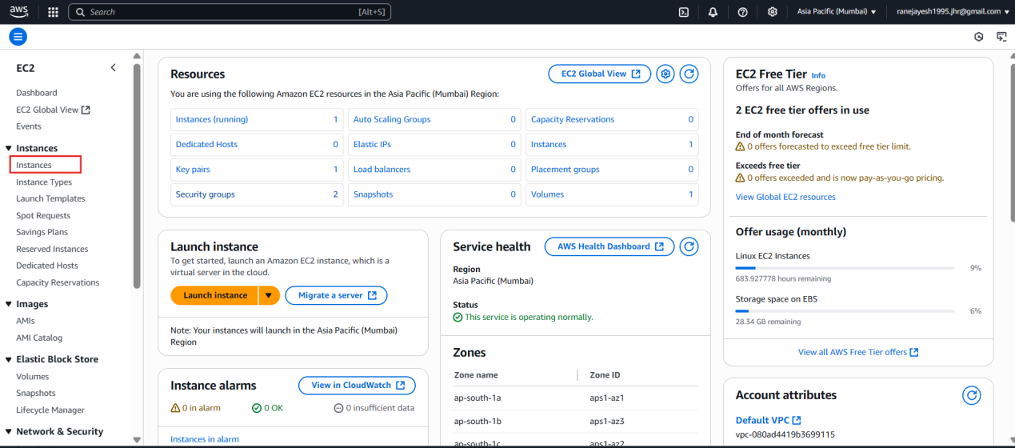

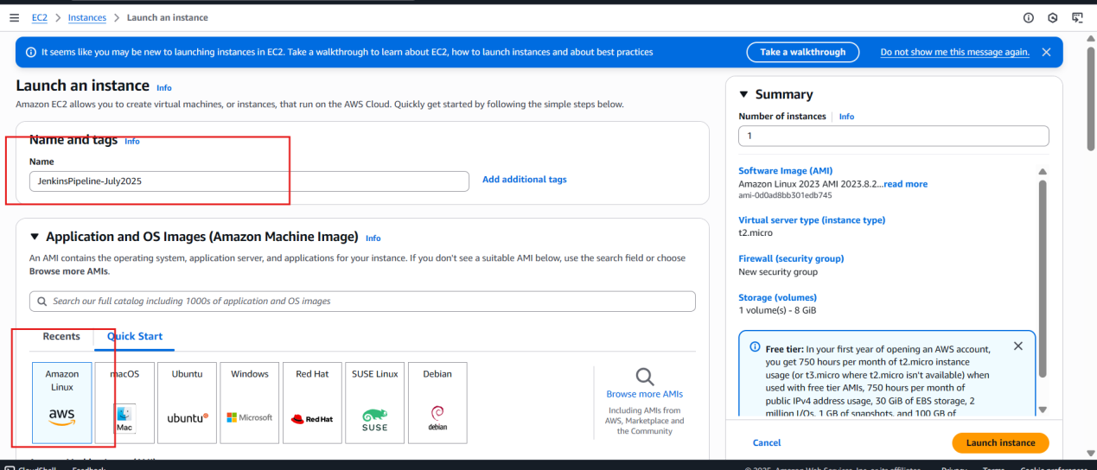

or

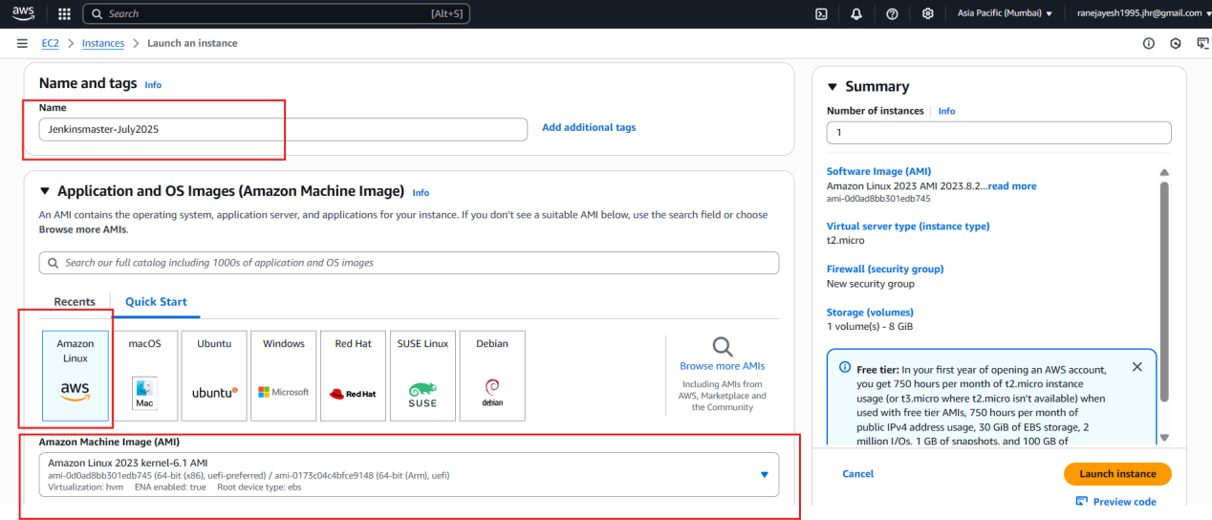

Based on our requirement we can choose t2.micro is free how many gb ram and gb cpu will be there but it will be slow

Charges applicable for below

T2.small charges will be applicable and it will work

T2.medium 2 vcpu 4gb memory for better performance

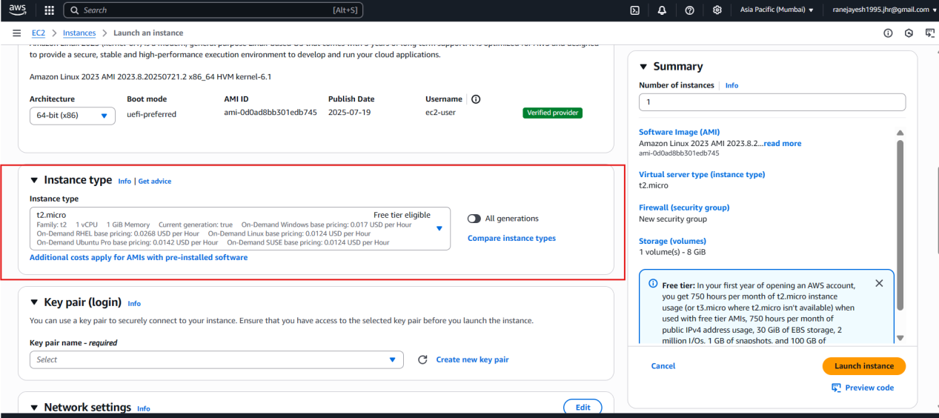

To create new key just use the tag and name copy and paste as in below and select as it is fiellds

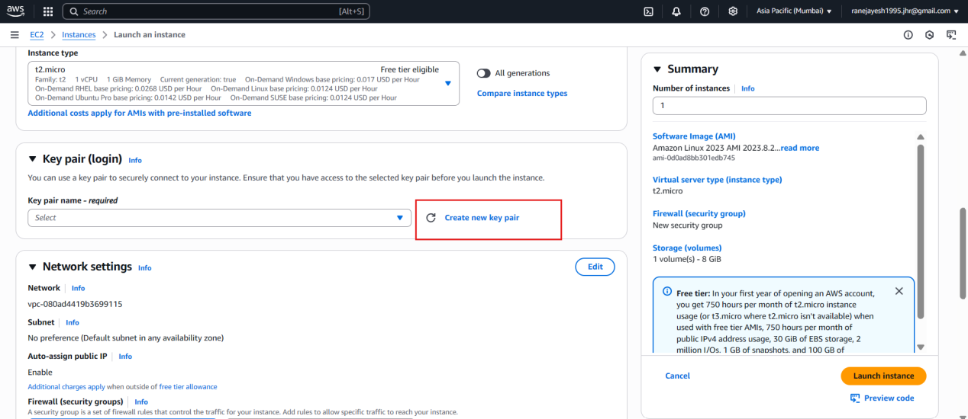

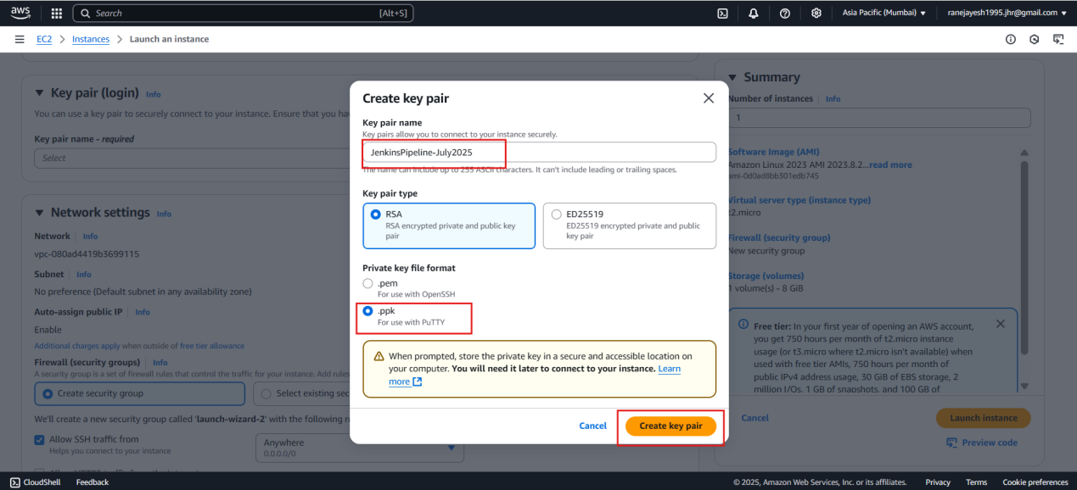

Once click on create key pair below ss you can see ppk keypair file will be downloaded

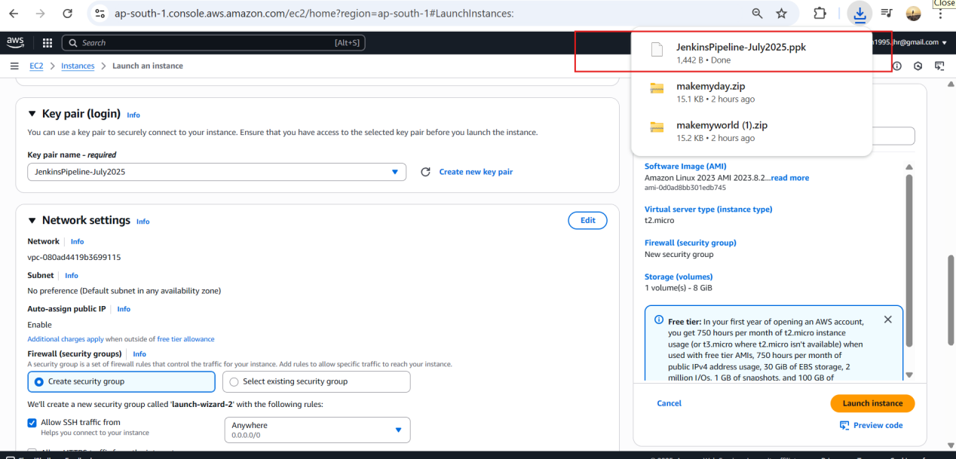

Simple click on launch instance

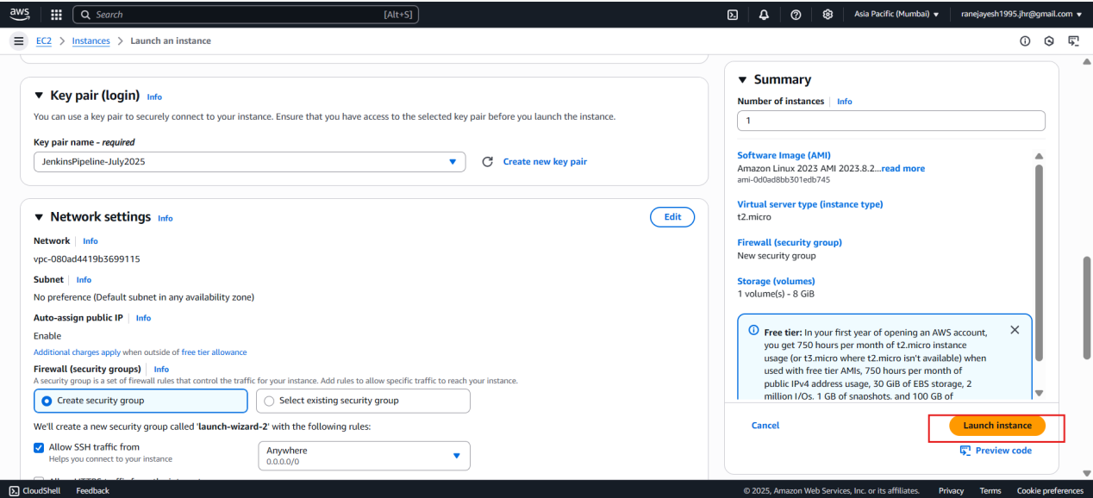

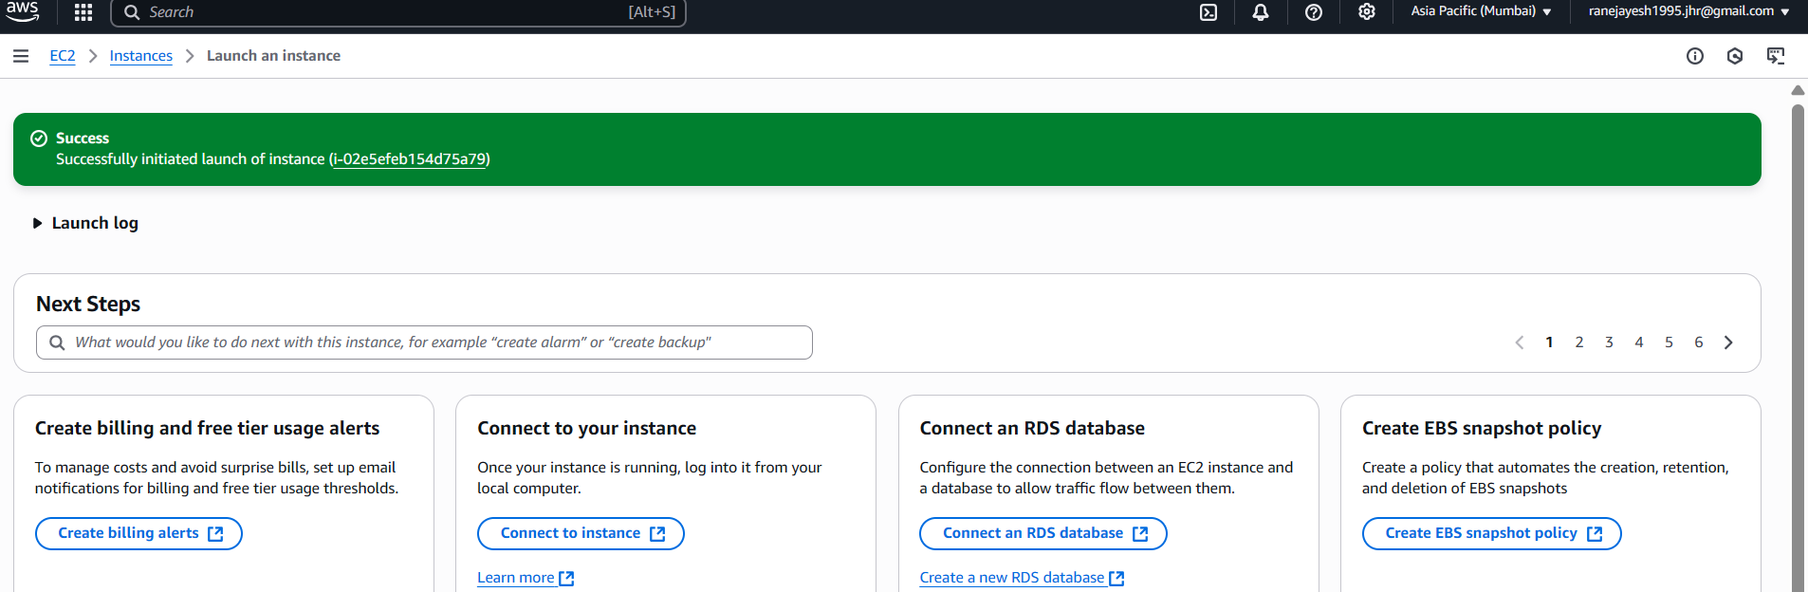

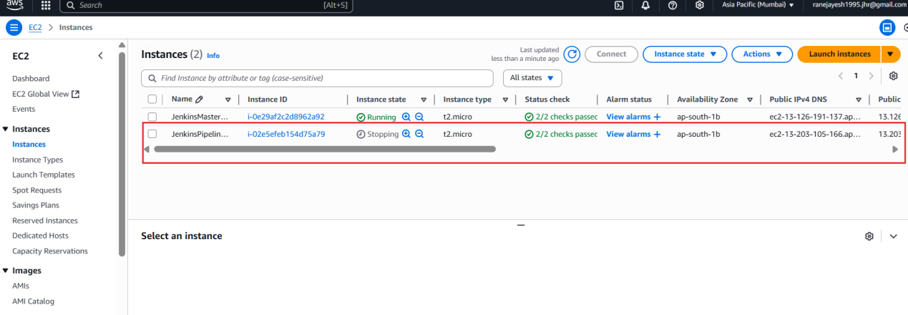

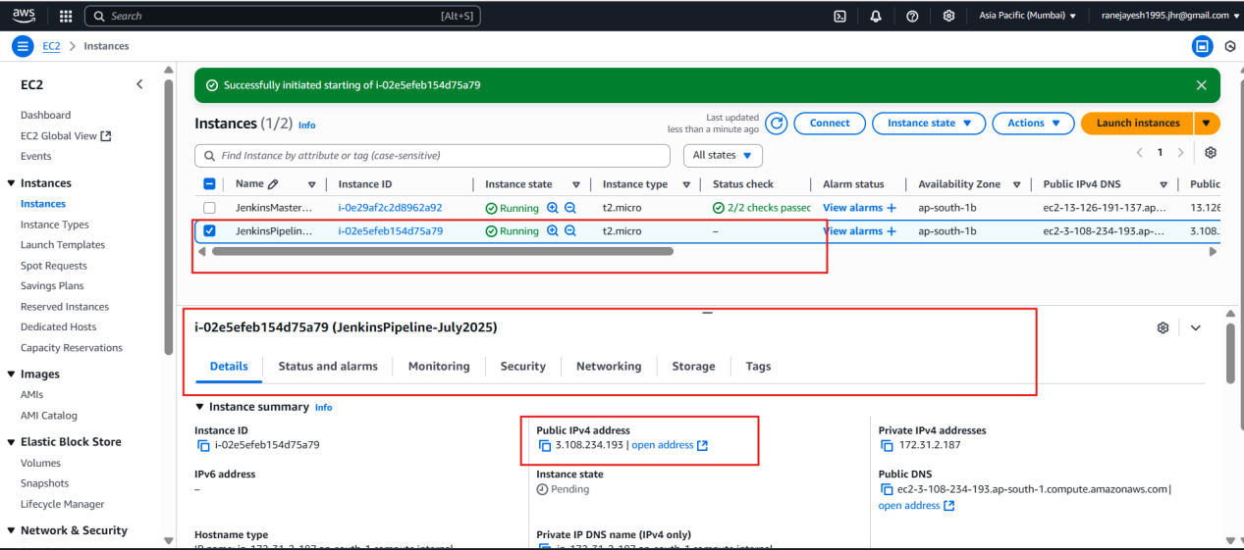

Incoming rules ( from ouside who will come in) we are going to touch incomming rule

Outgoing rules (viseversa)

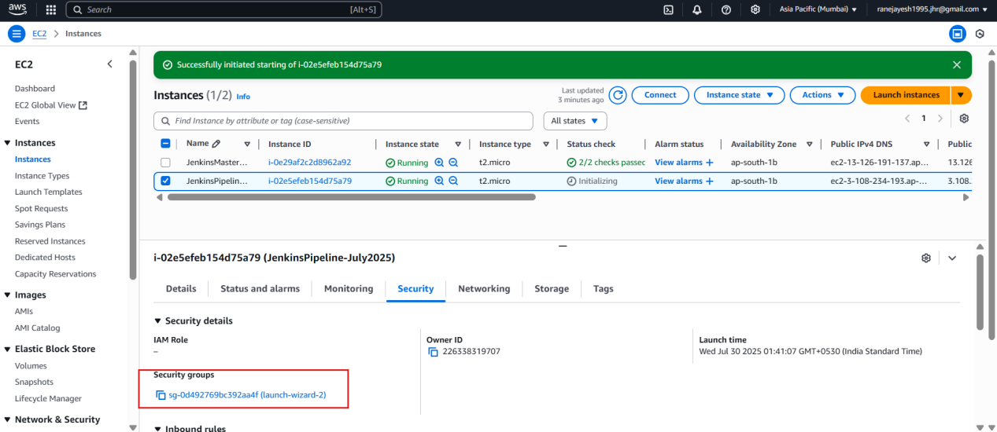

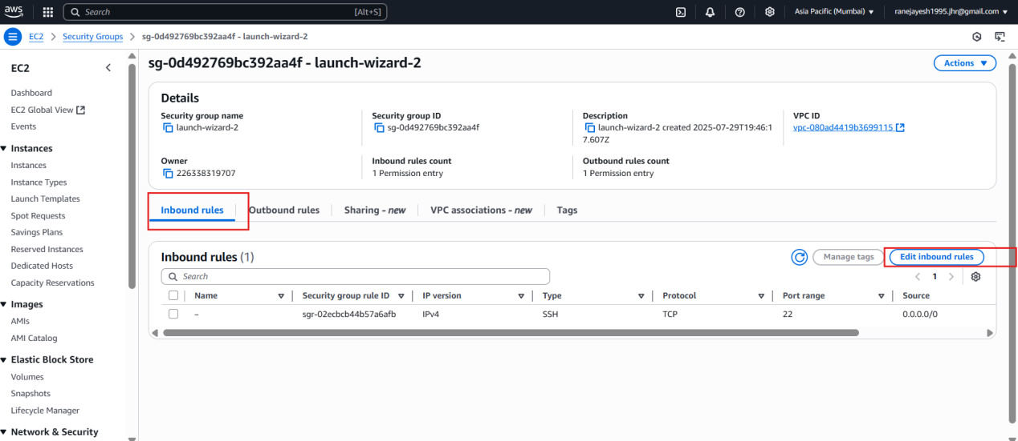

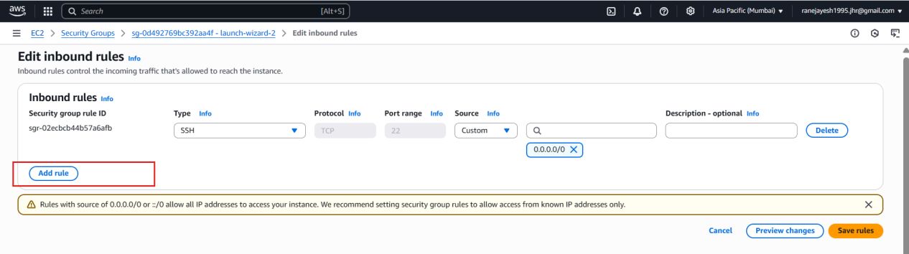

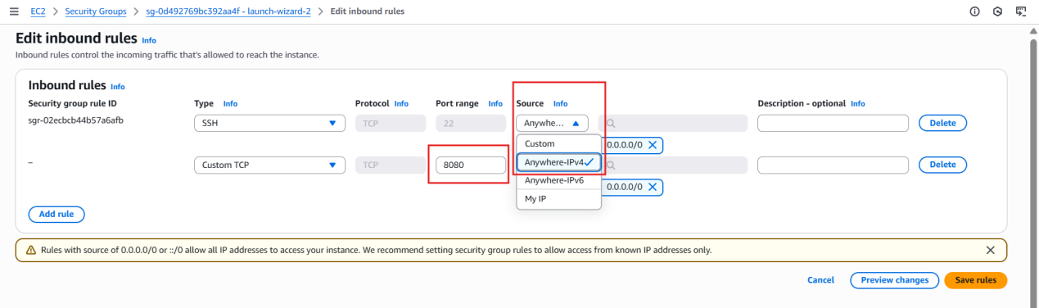

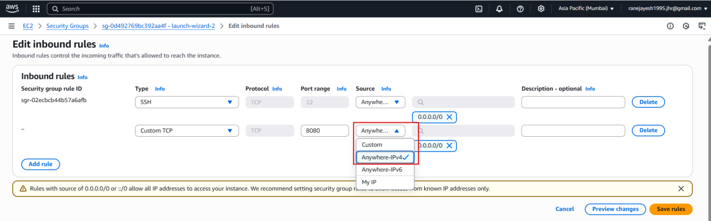

Save rules

Because jenkins run on port number 8080   
you can see the below inbound rules after saving

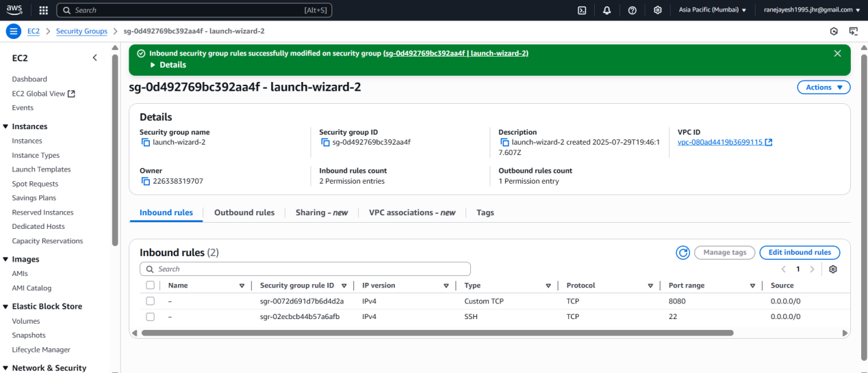

Then after that

**Use Public IPv4 address of created instance to add in putty**

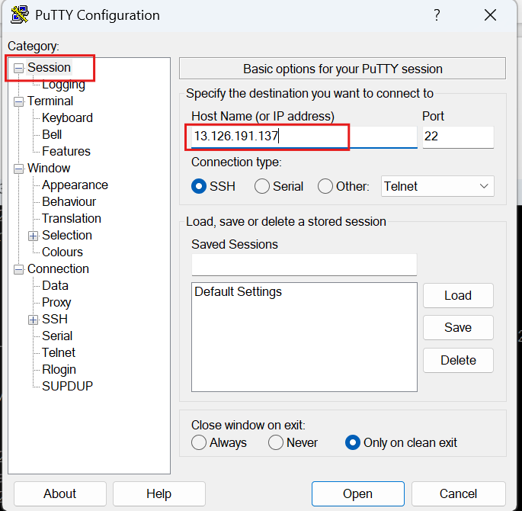

Browse that ppk file which was downloaded at the time of instance create new key pair

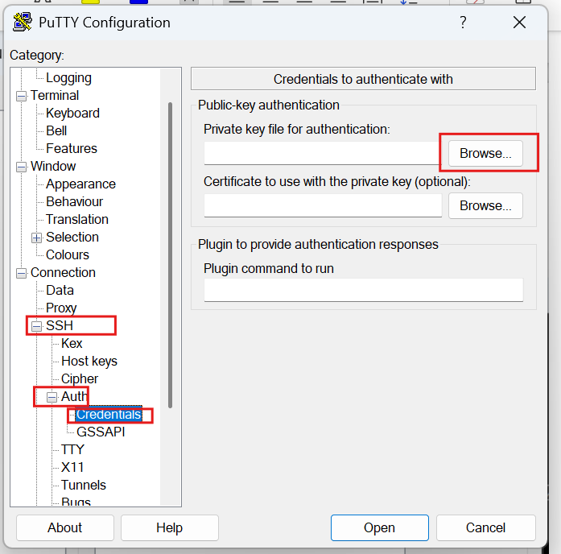

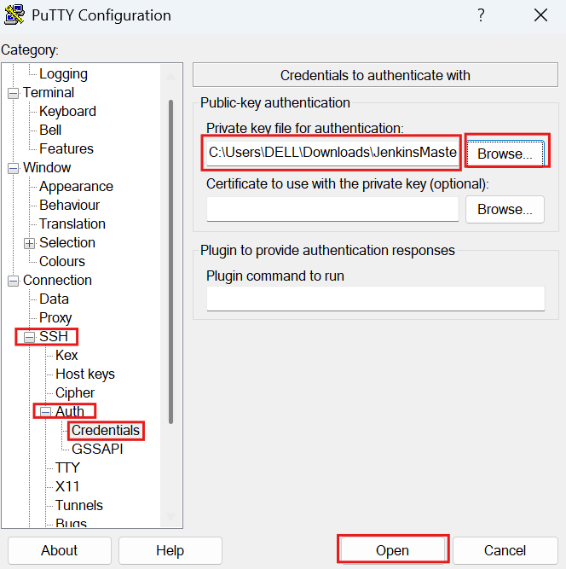

s

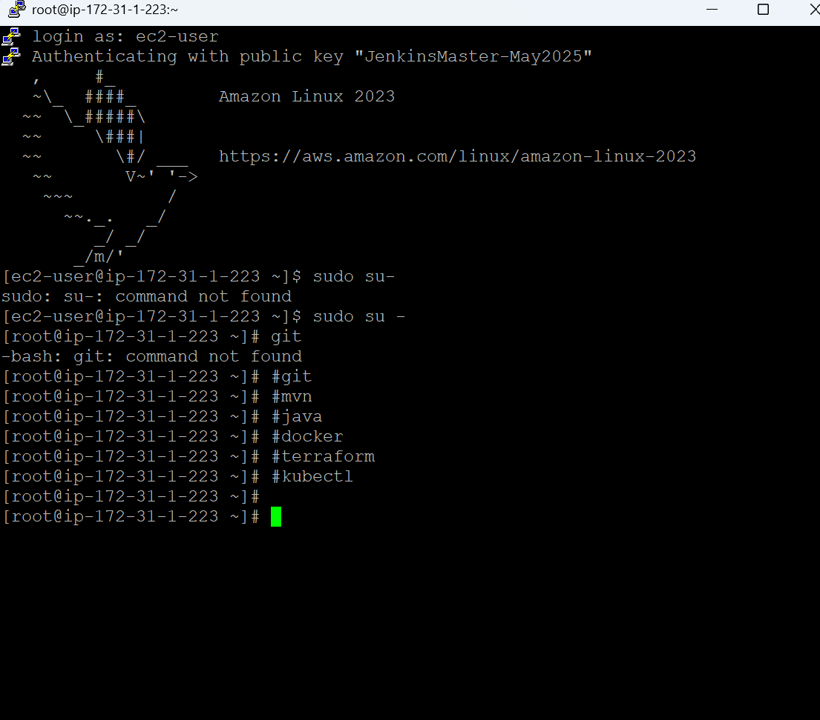

1

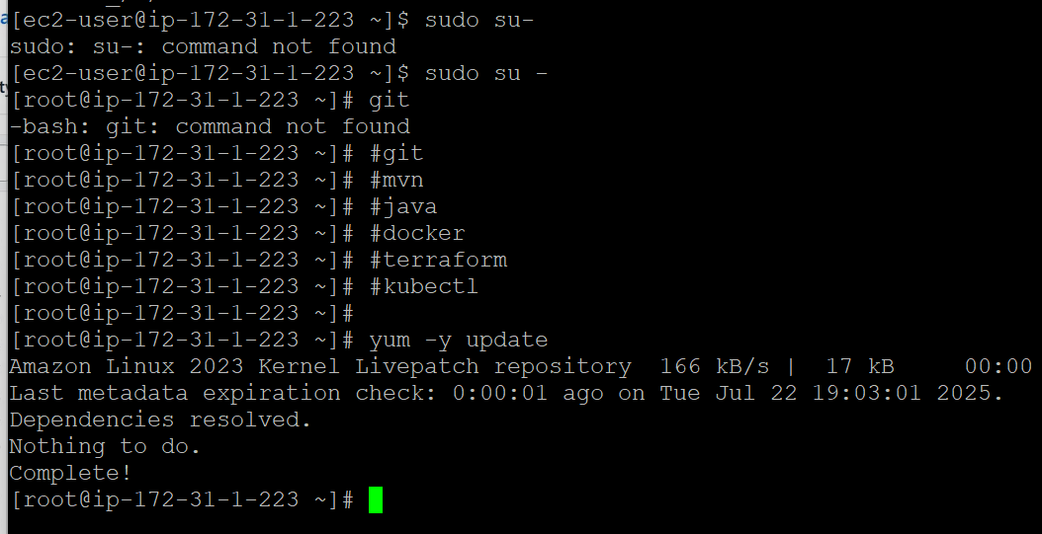

2

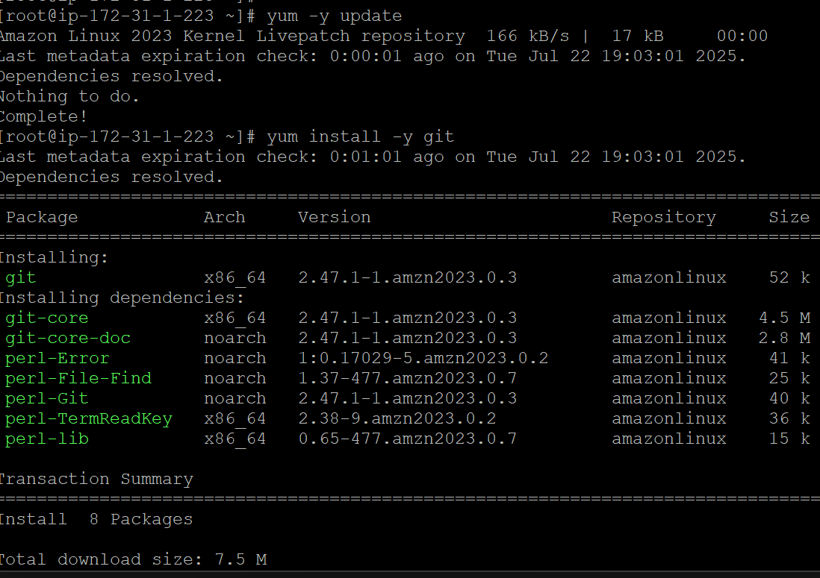

3

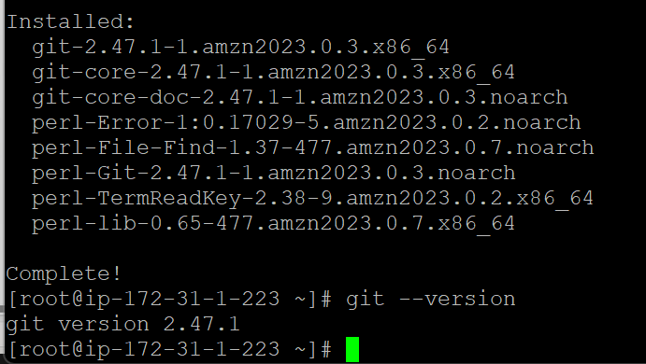

4

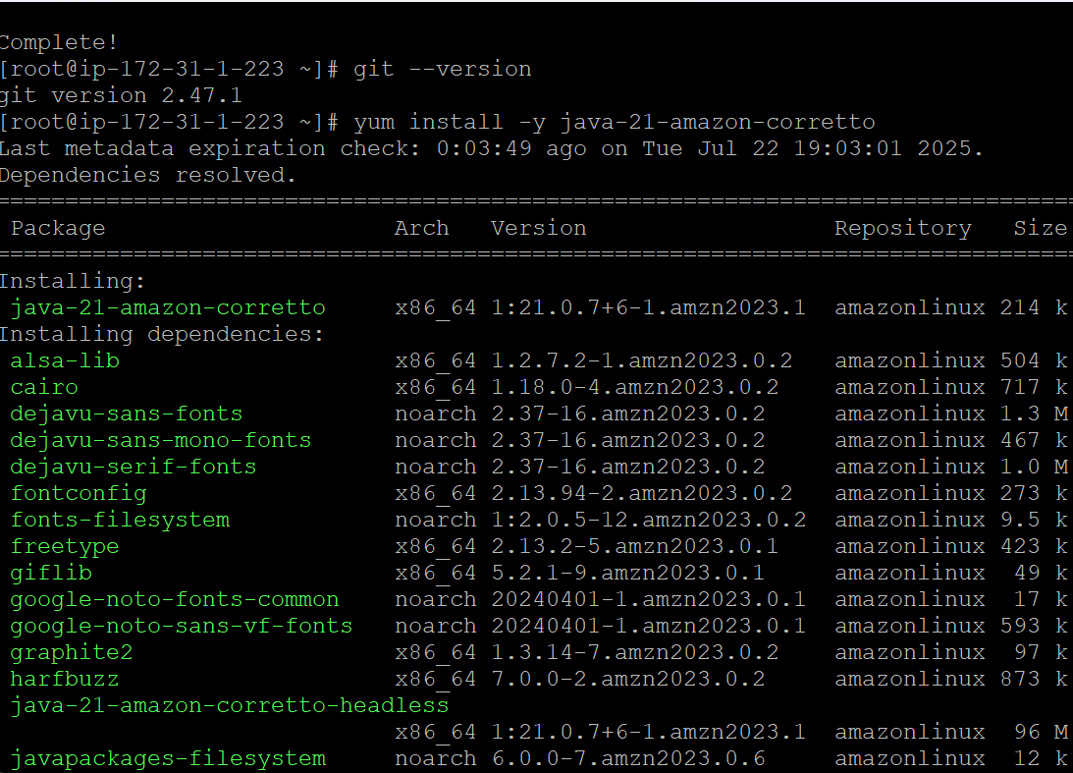

5

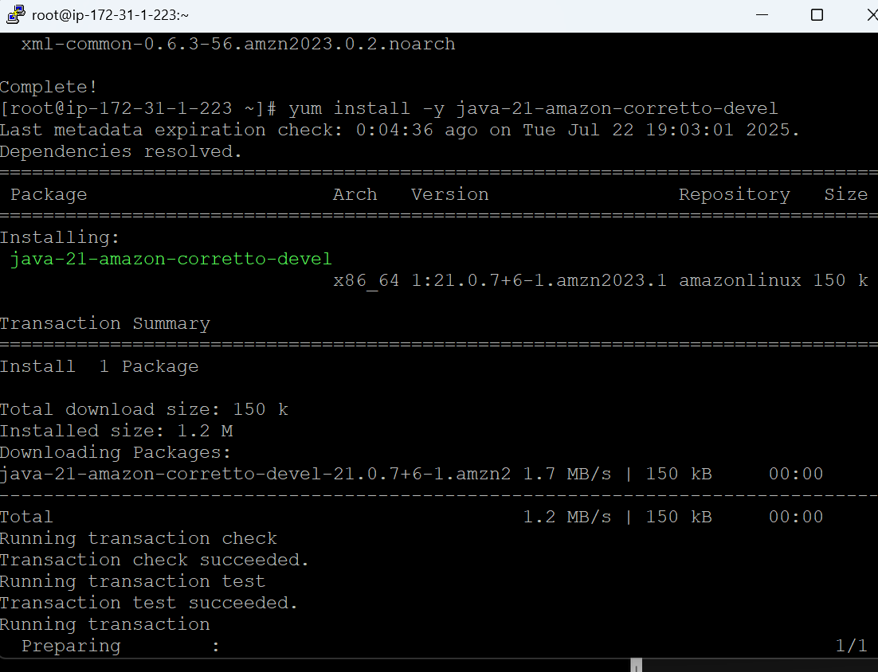

6

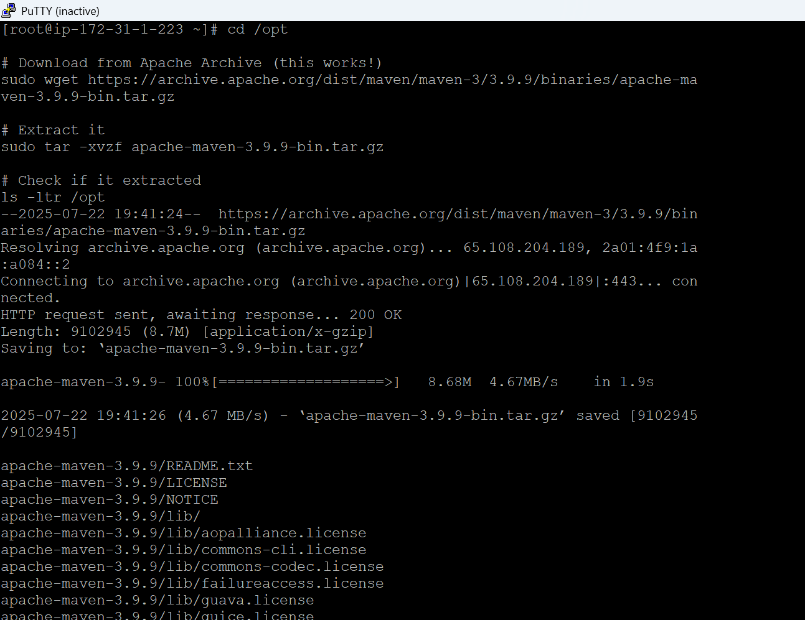

7

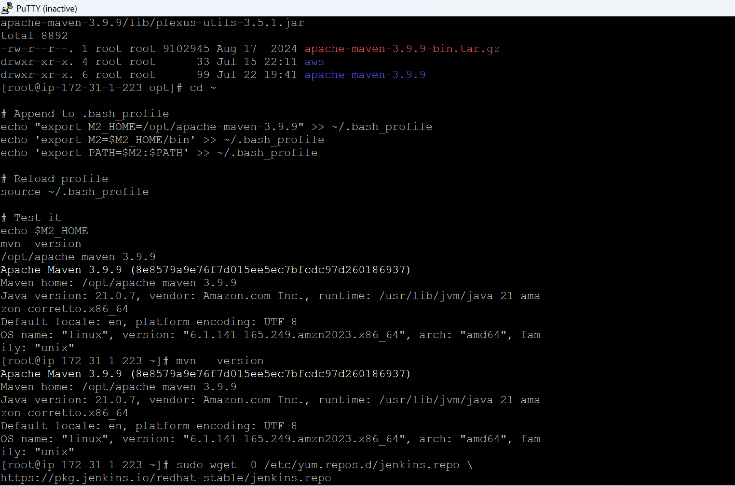

8

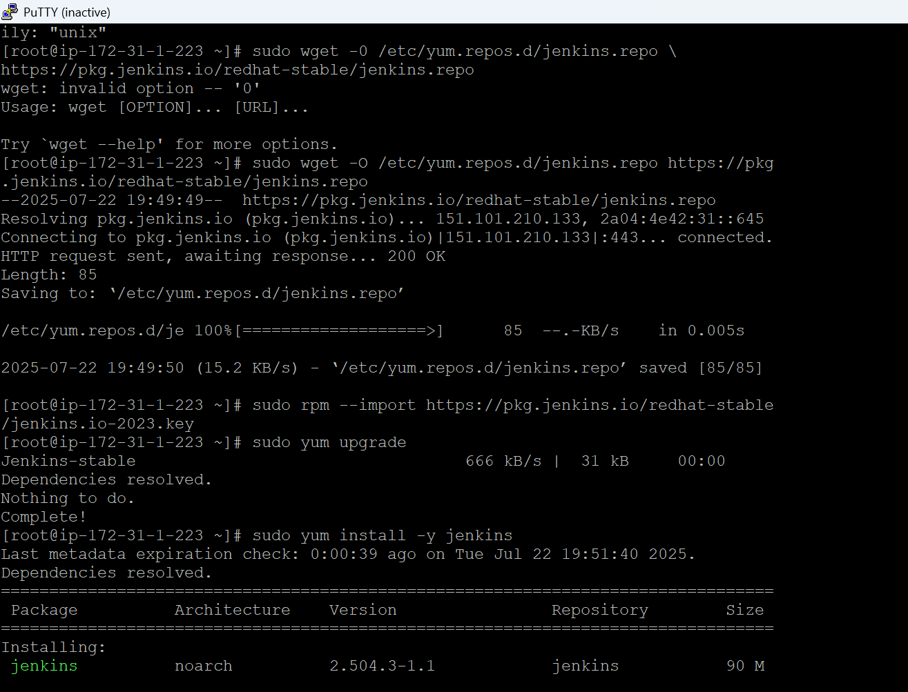

9

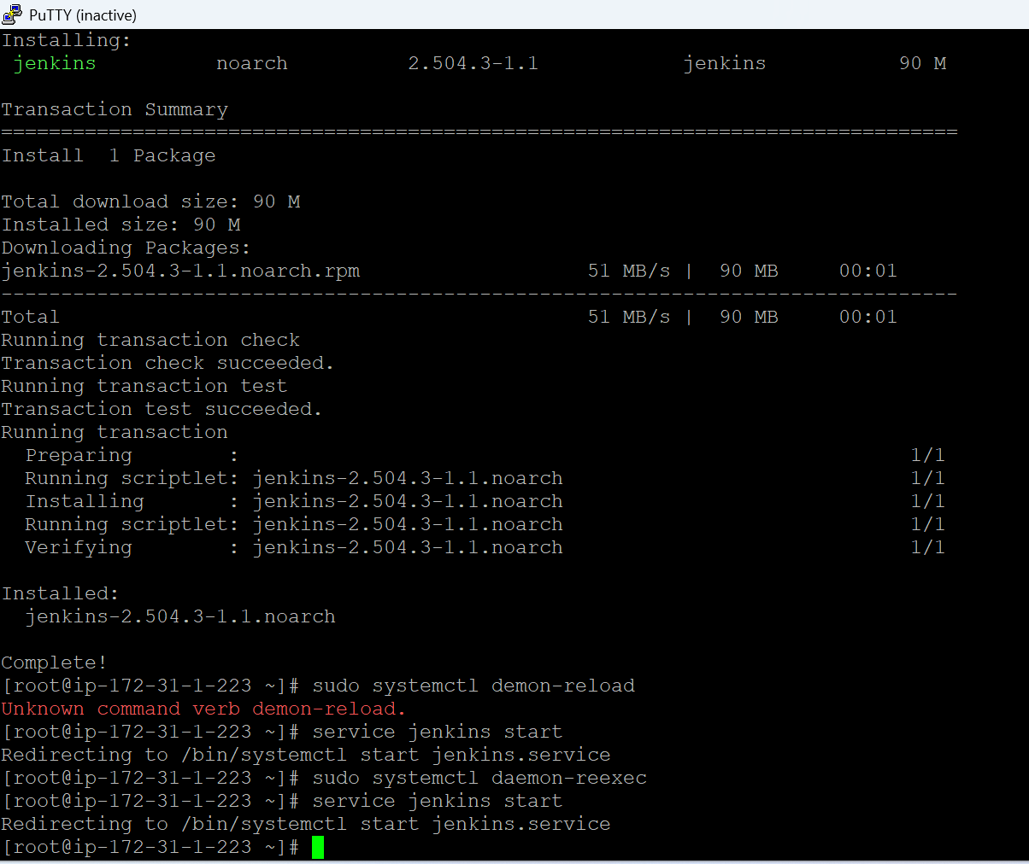

10

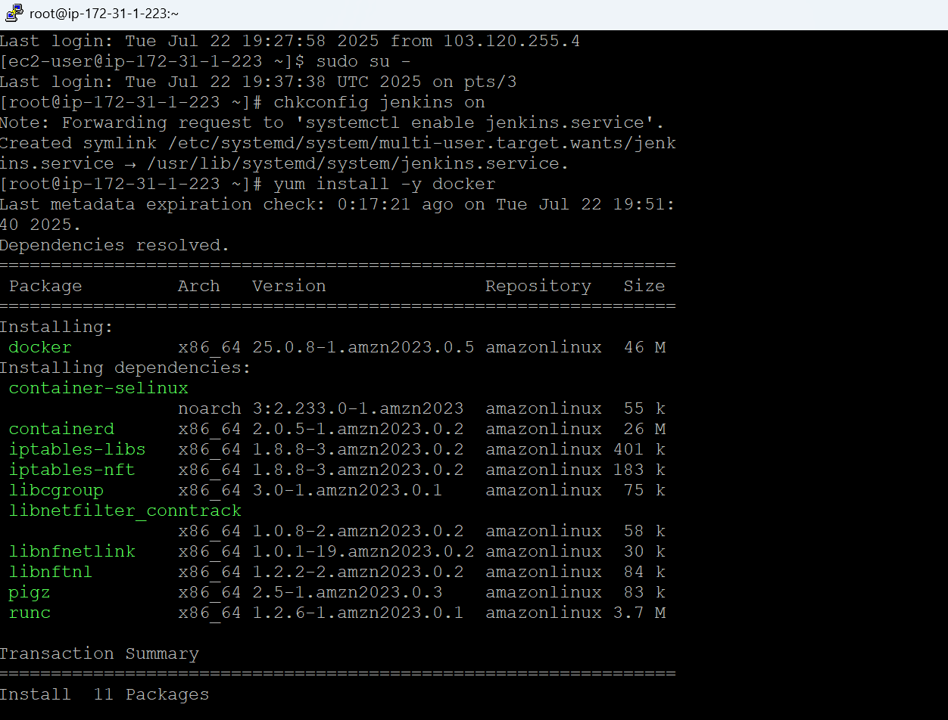

11

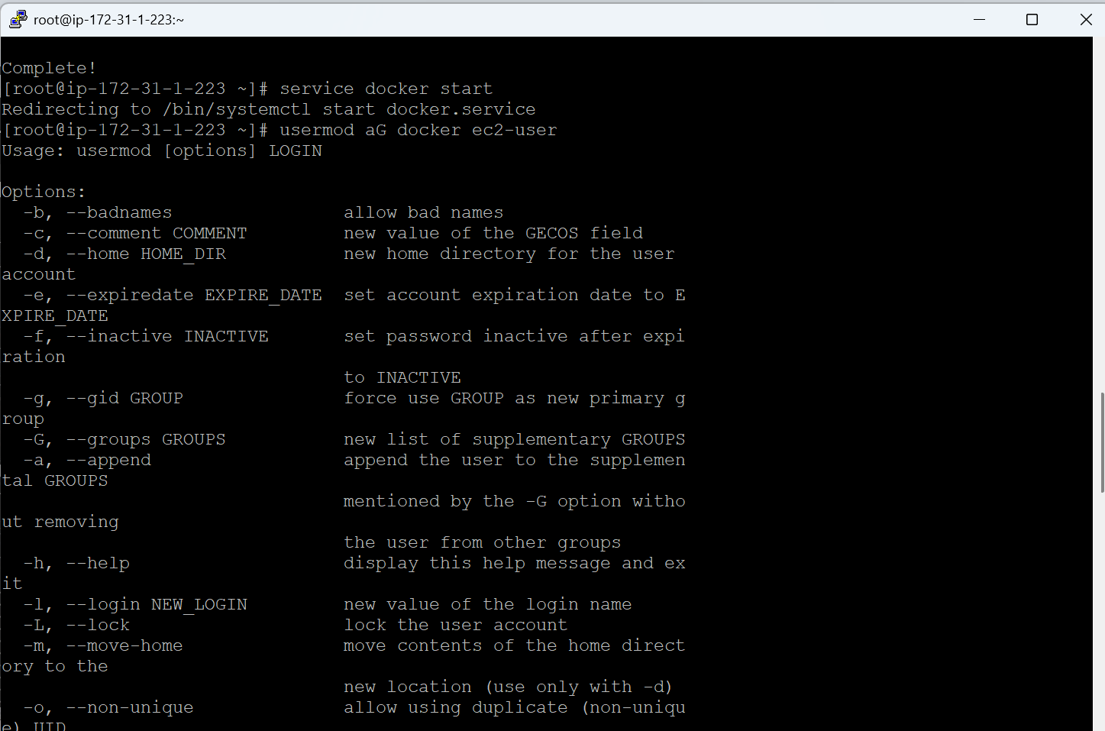

12

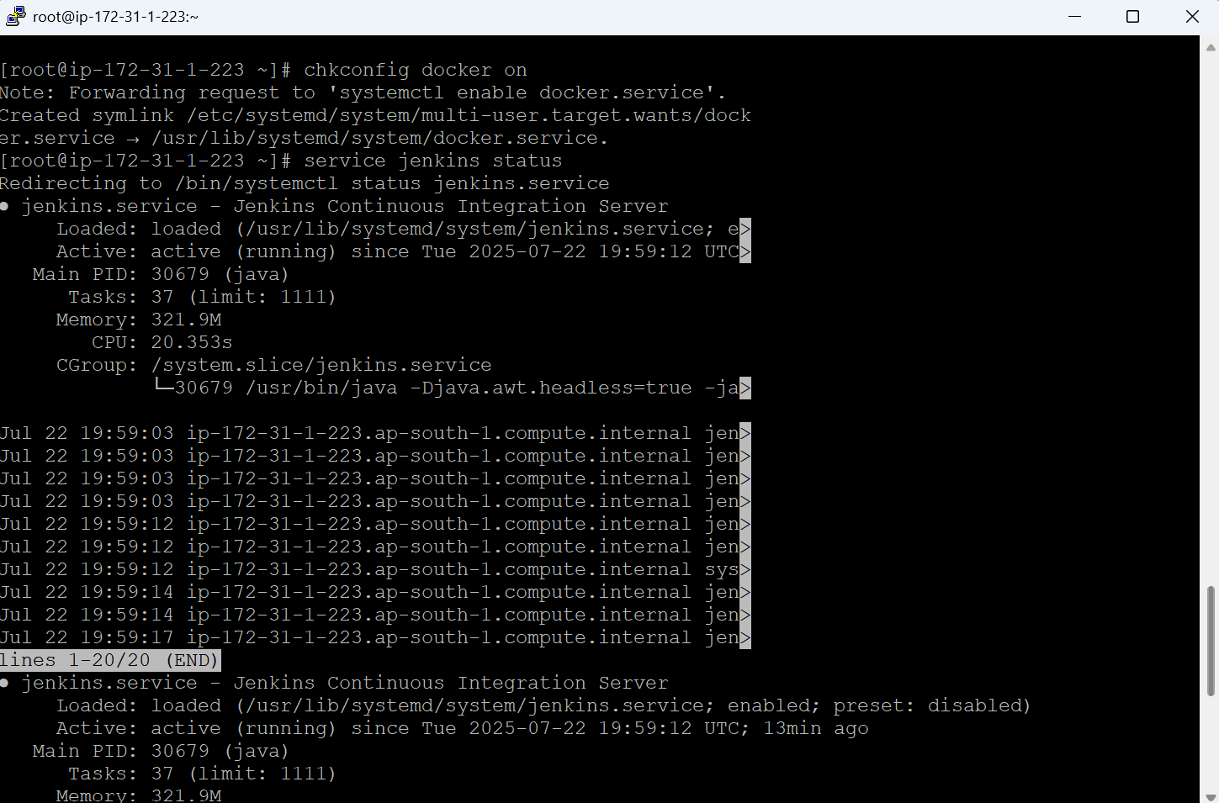

13

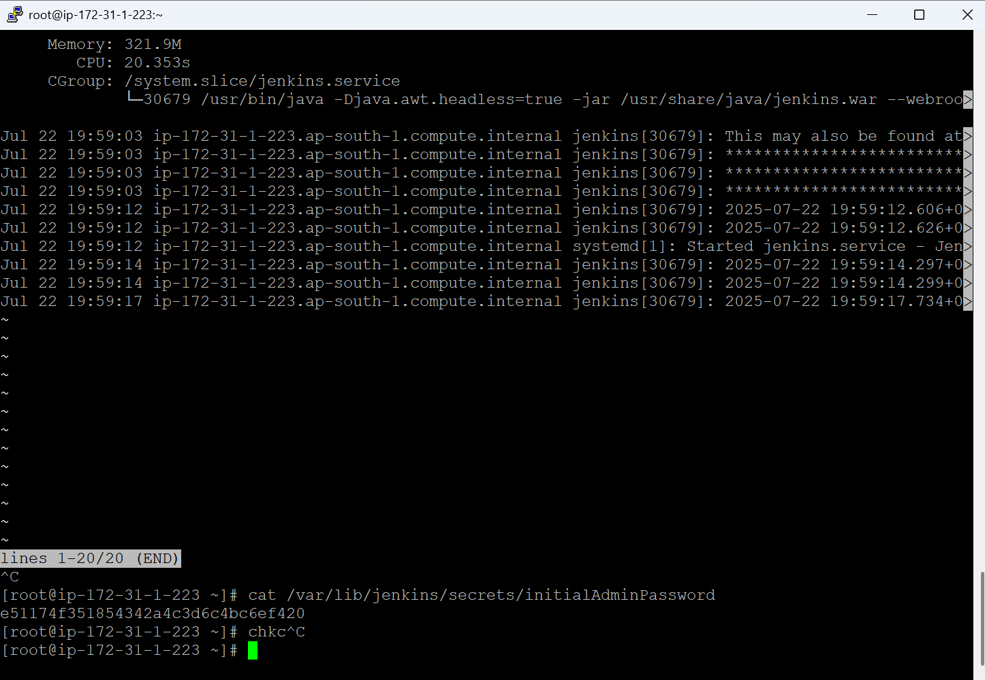

14

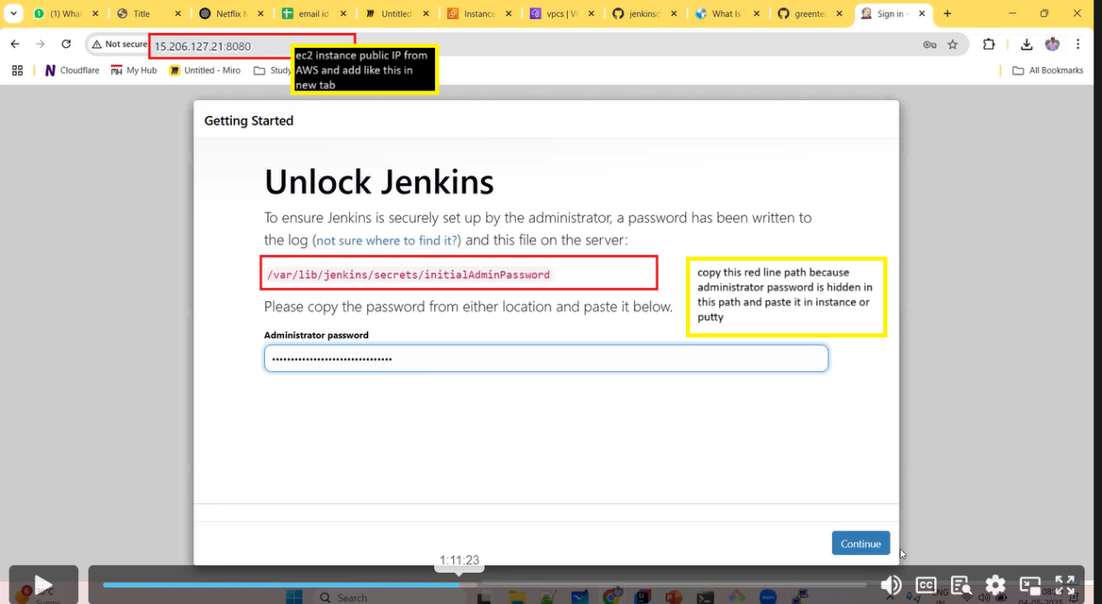

15

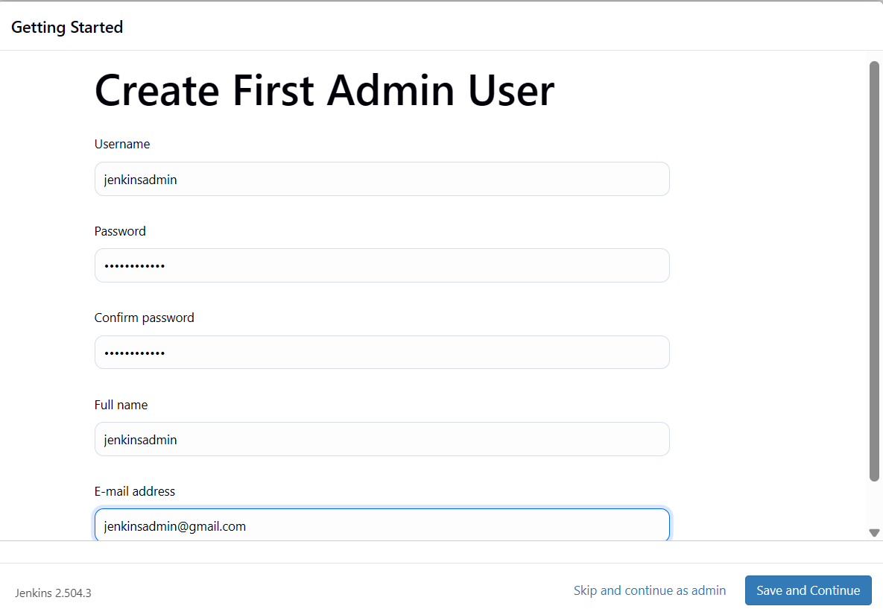

16

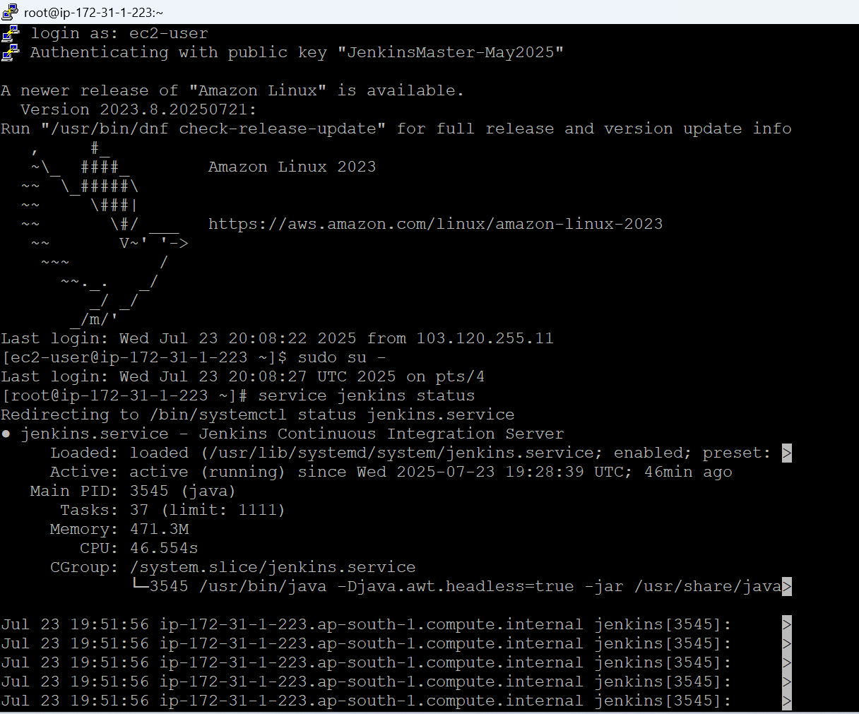

17

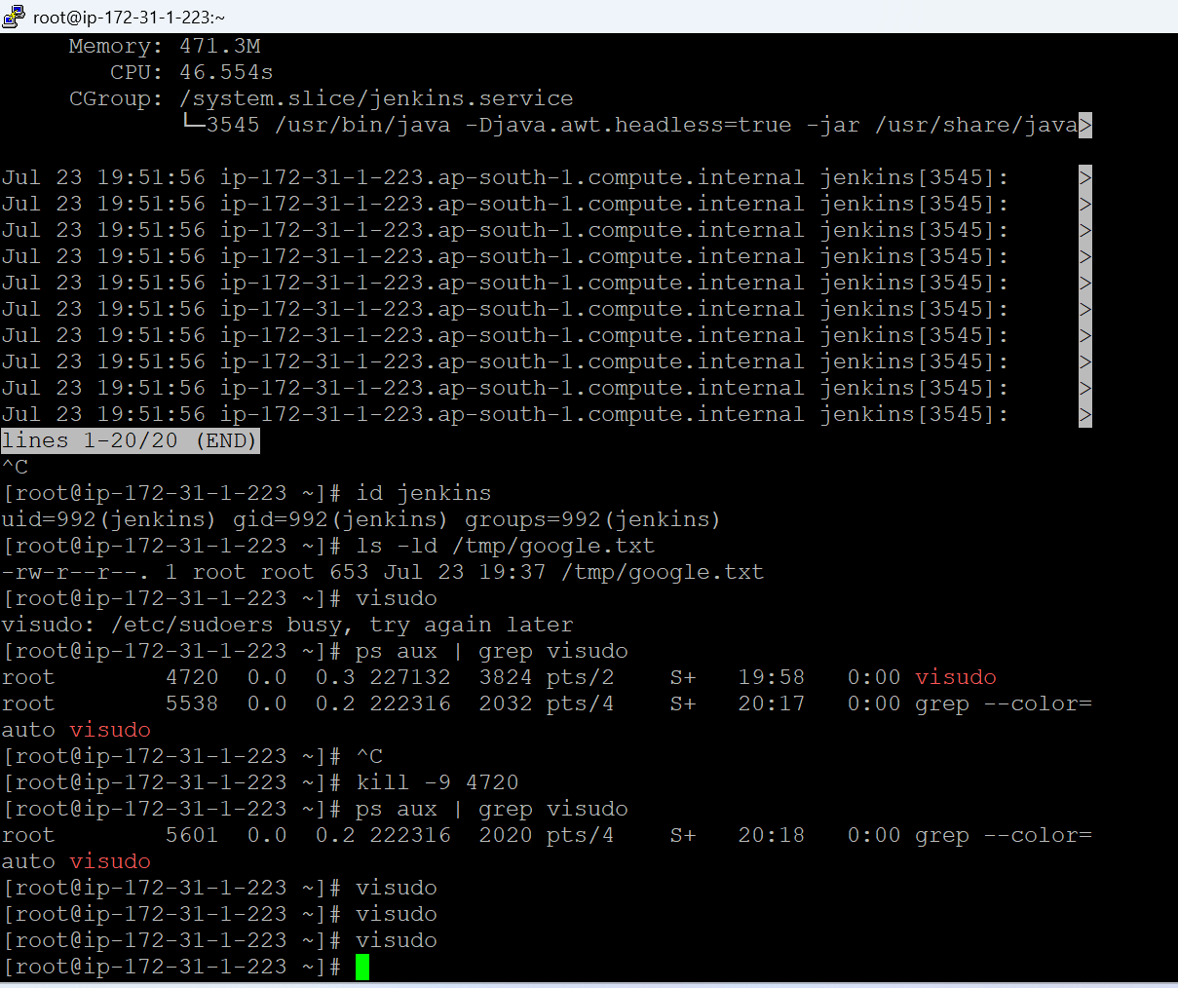

18

To give the access to jenkins we have to use this above and below command 18 and 19 20 maybe  
and this below line at same position we have to add

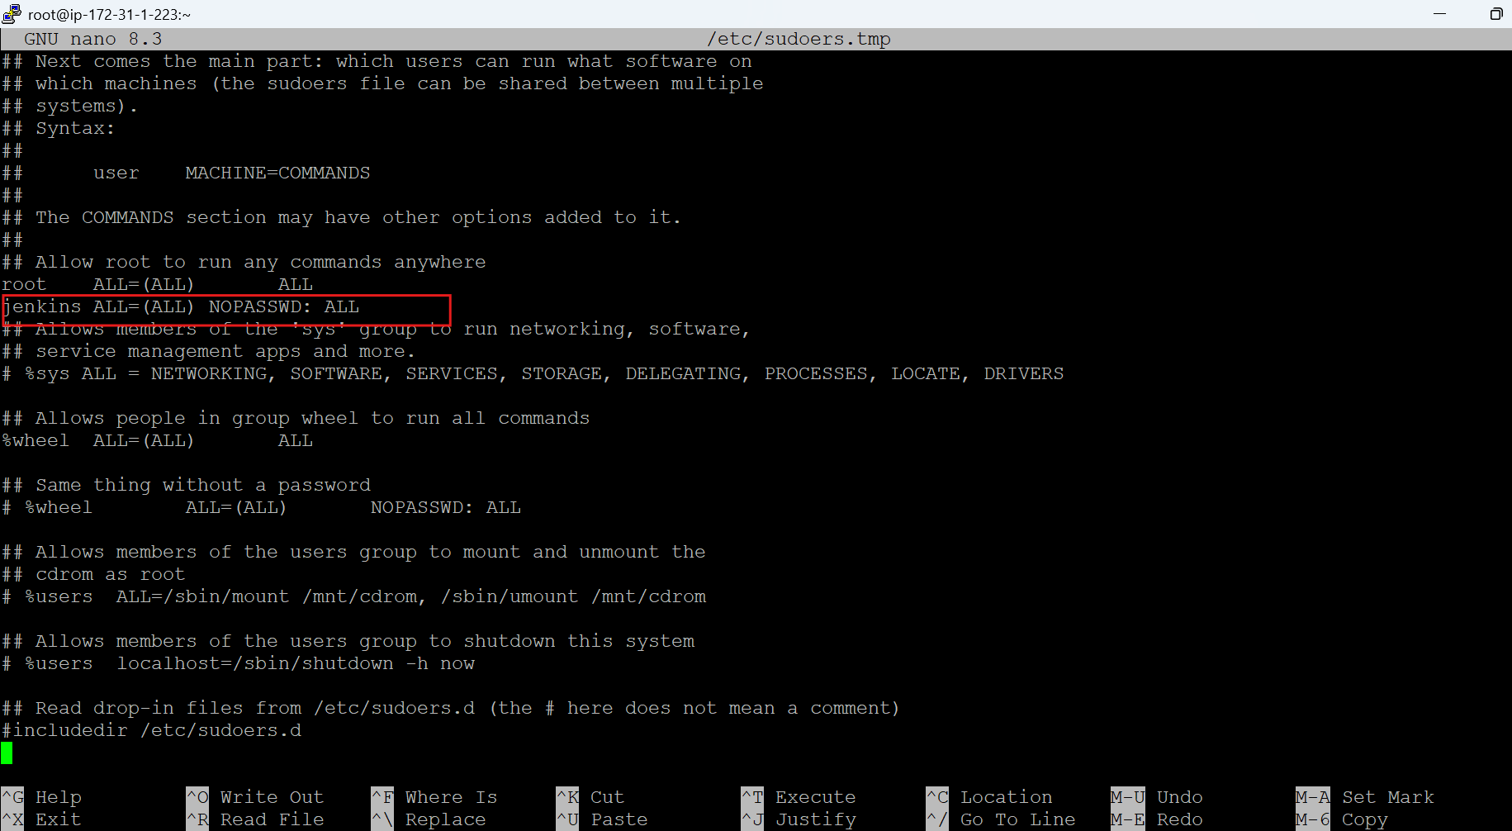

19  
jenkins ALL=(ALL) NOPASSWD: ALL   
add this as above ss

To save

Ctrl + s

Ctrl + x

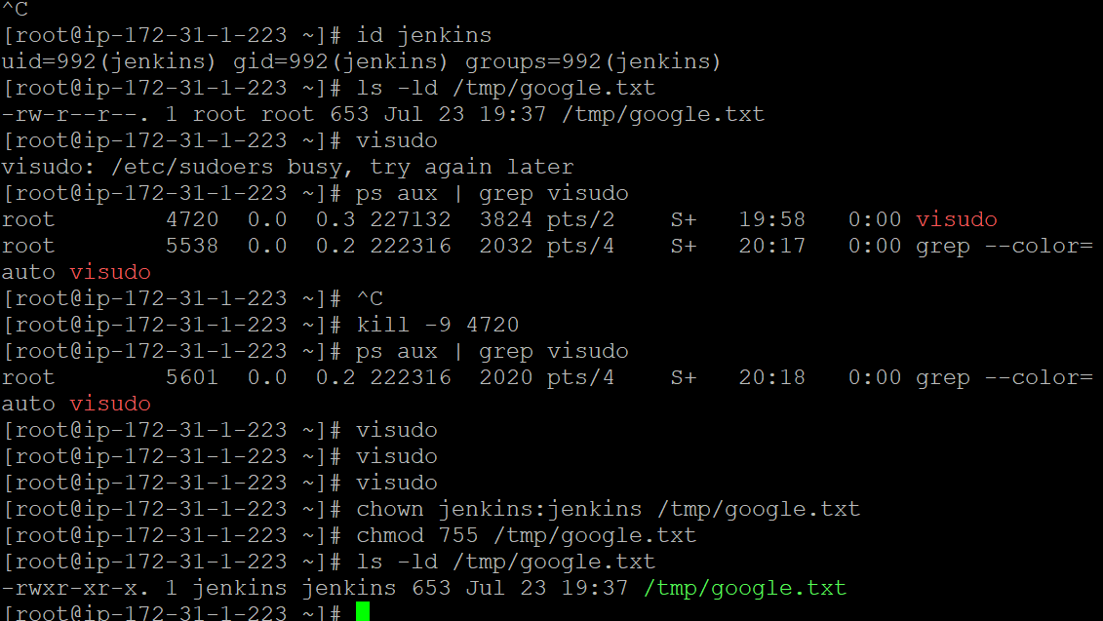

20

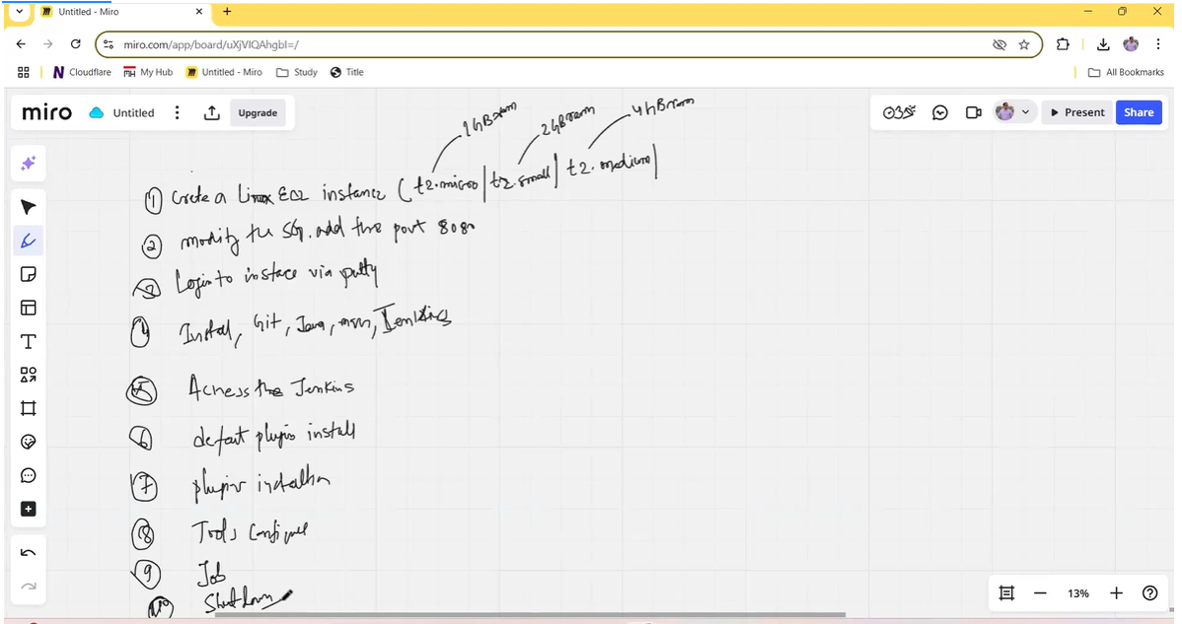

21

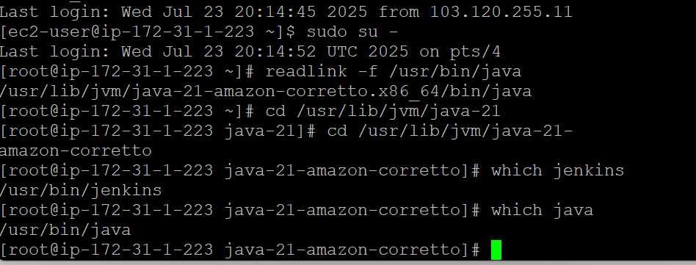

22

Jenkins login by public instance ip

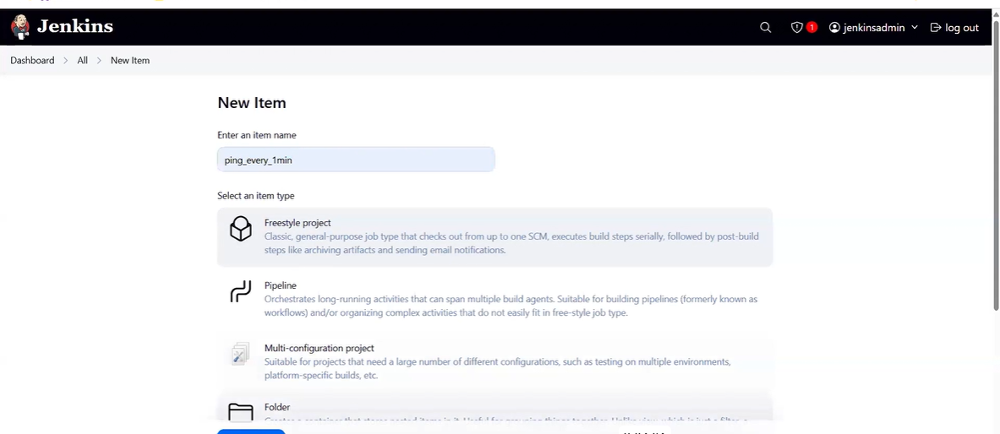

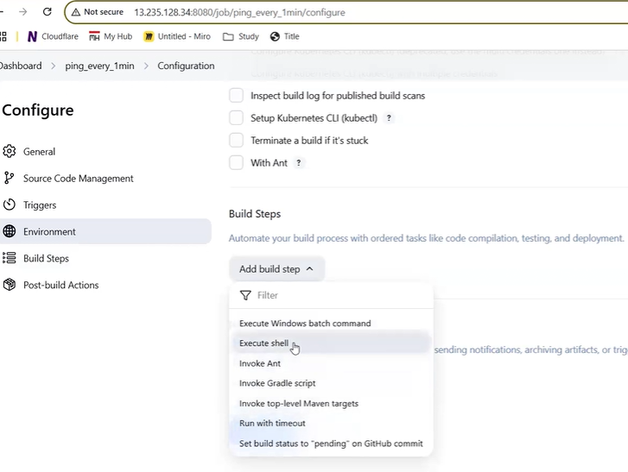

==

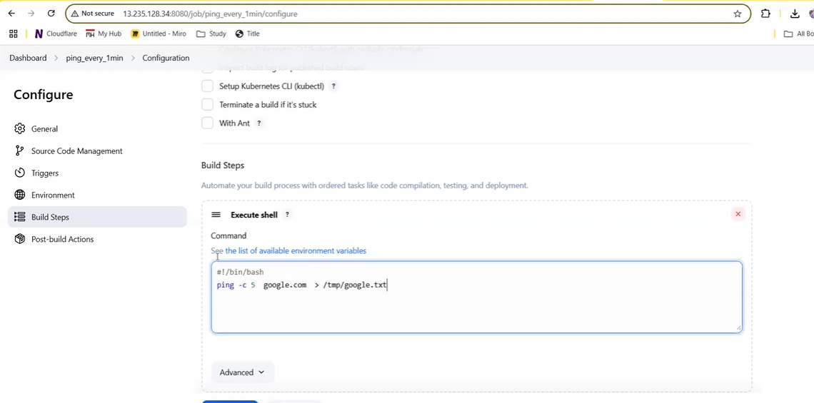

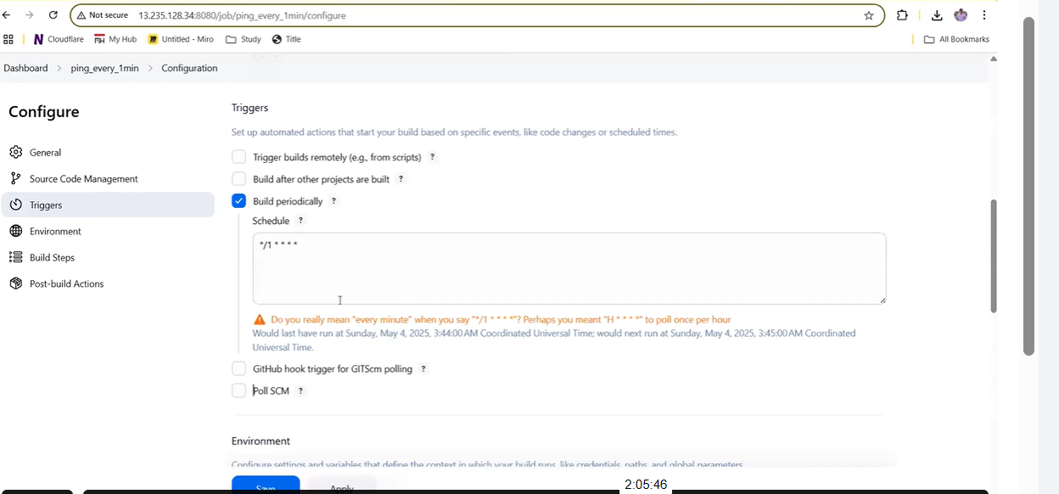

Click

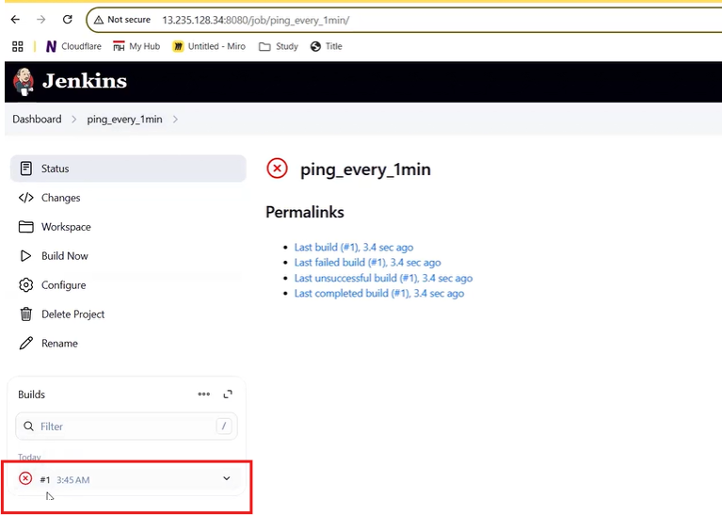

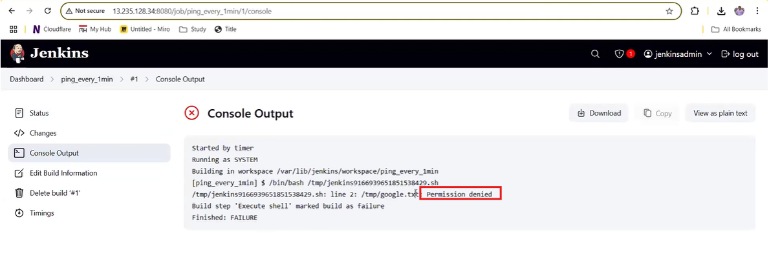

This path we have to set THE path of java below is the path we can get

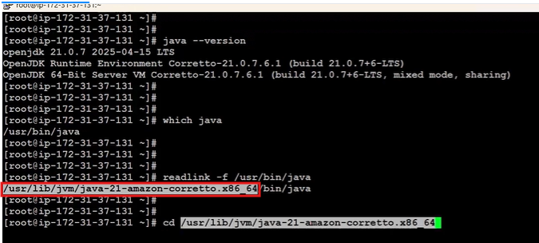

==

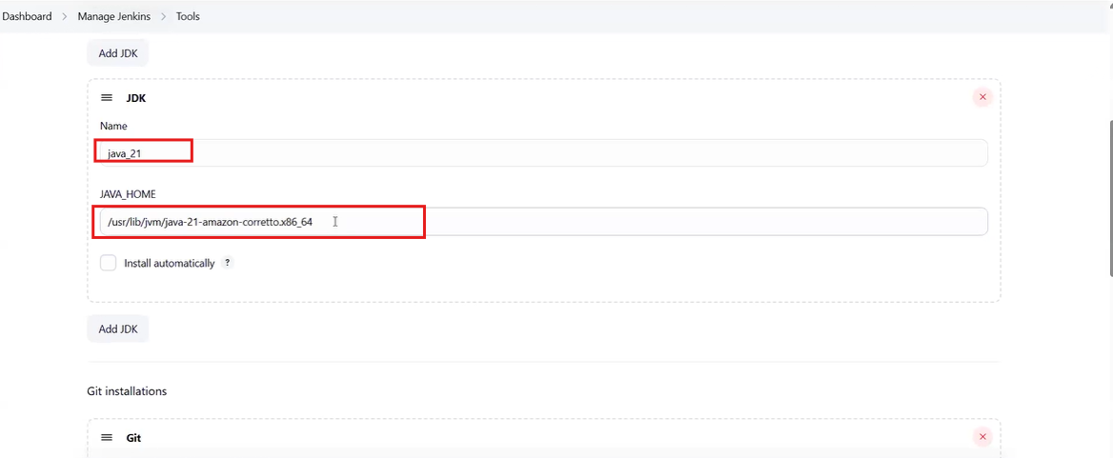

To set the git path

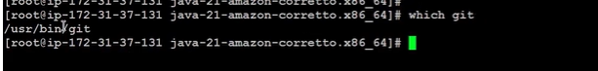

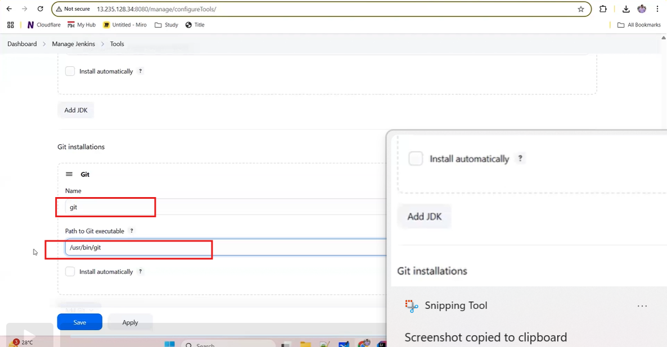

Set the maven path



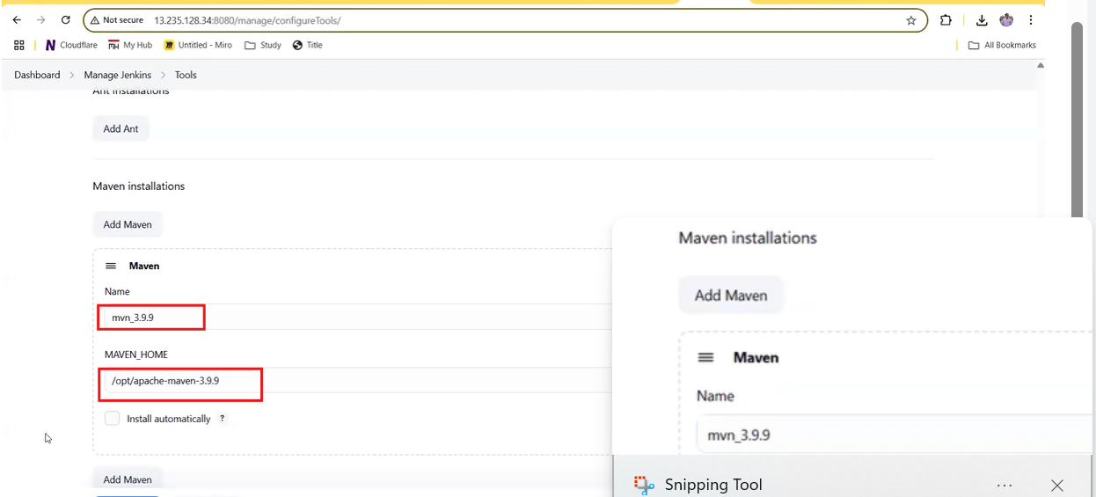

Maven pipeline

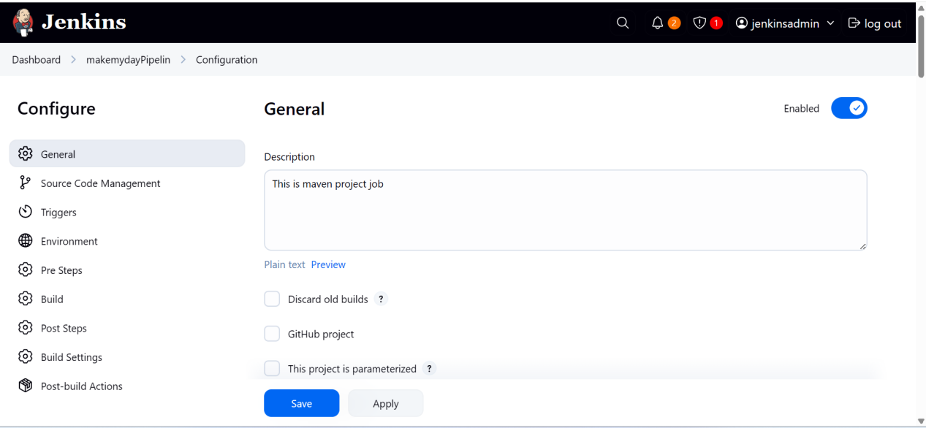

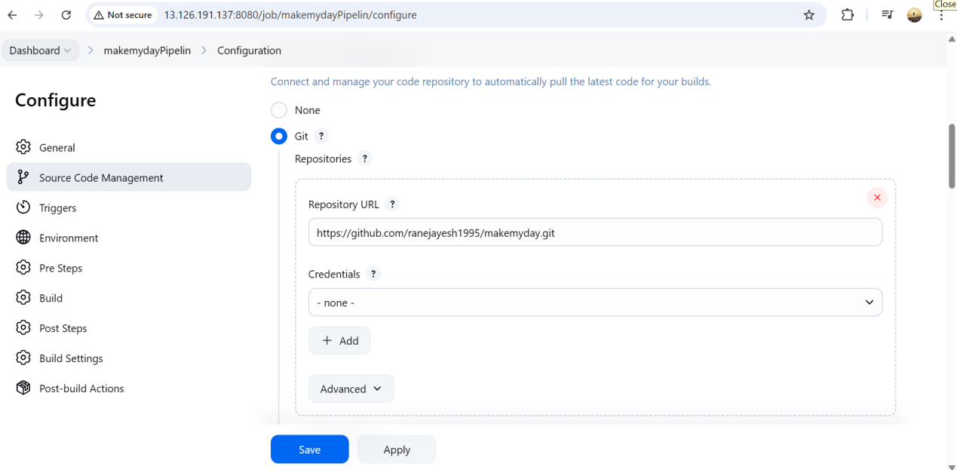

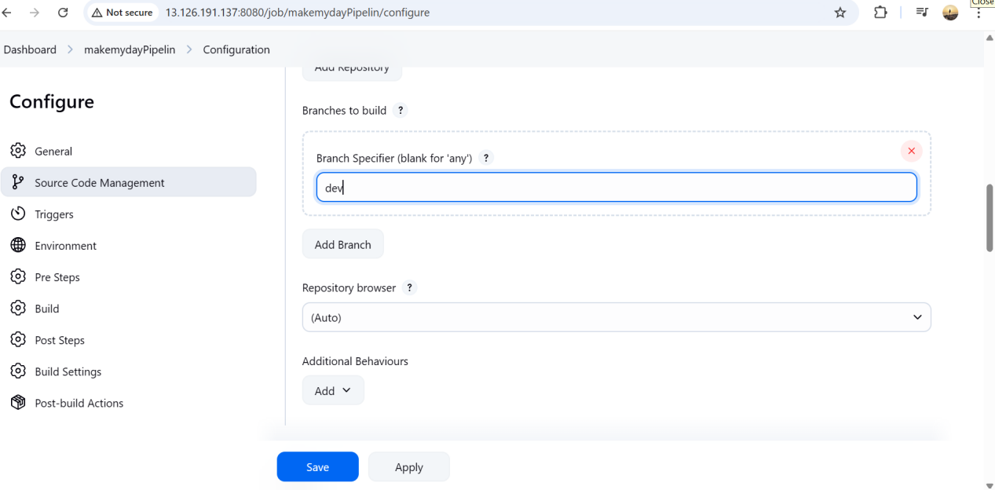

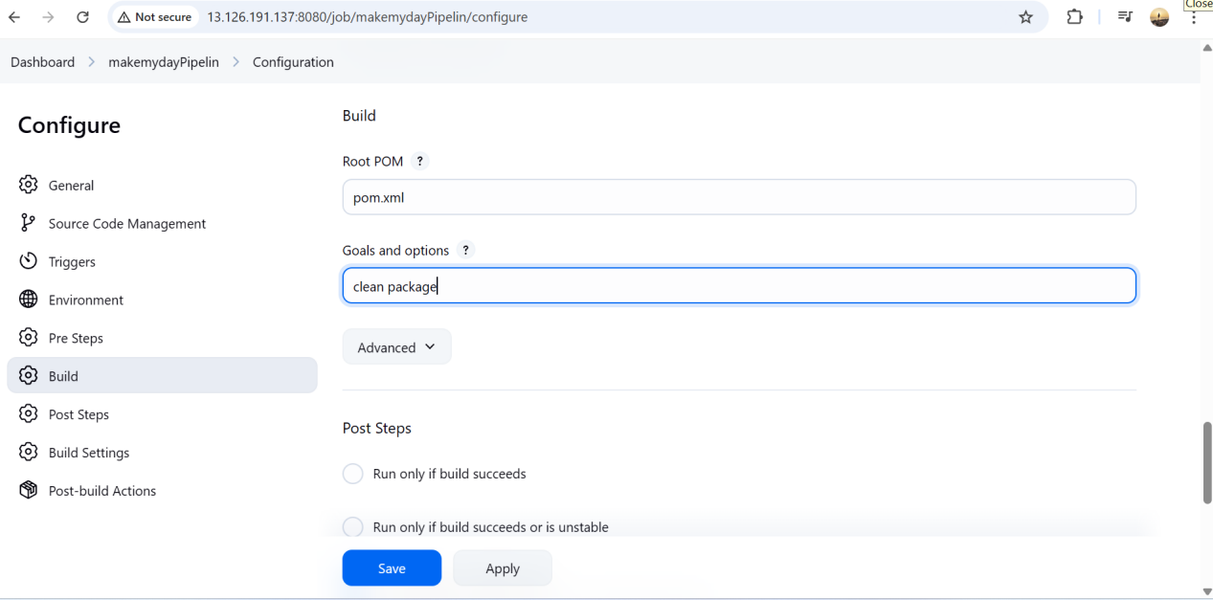

FIRST SET THE BELOW

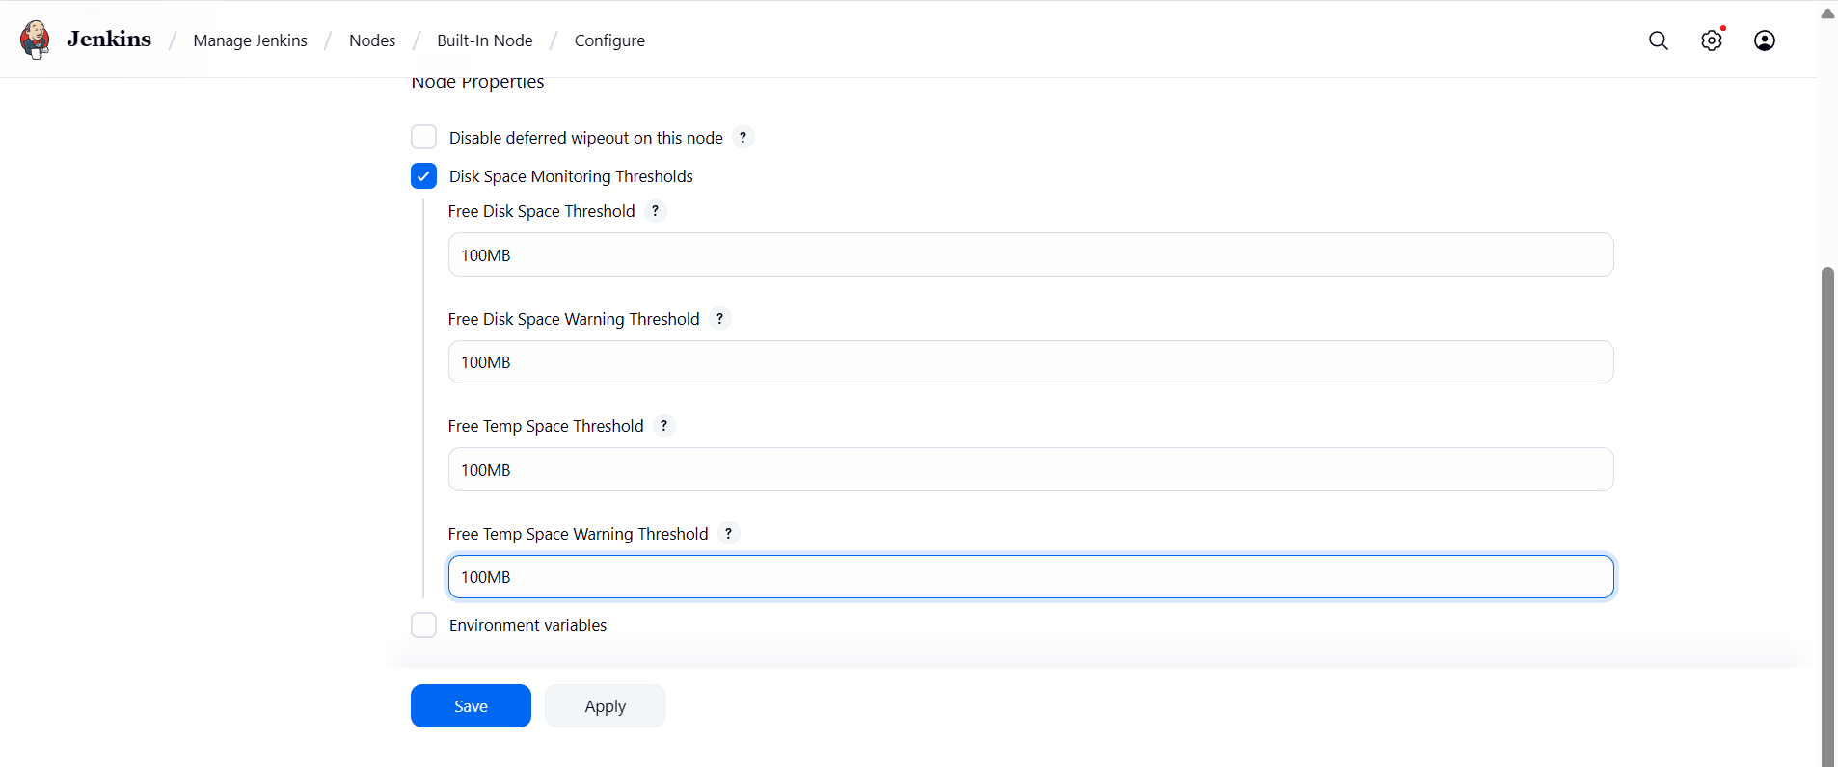

To create txt file

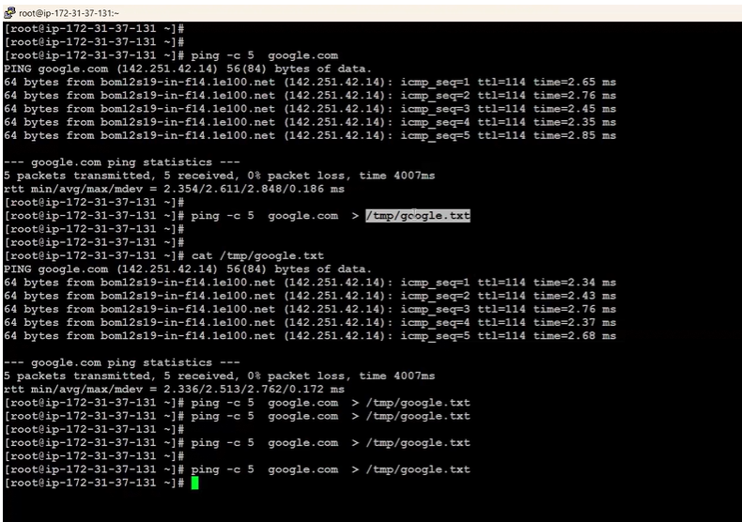

To give the read write access

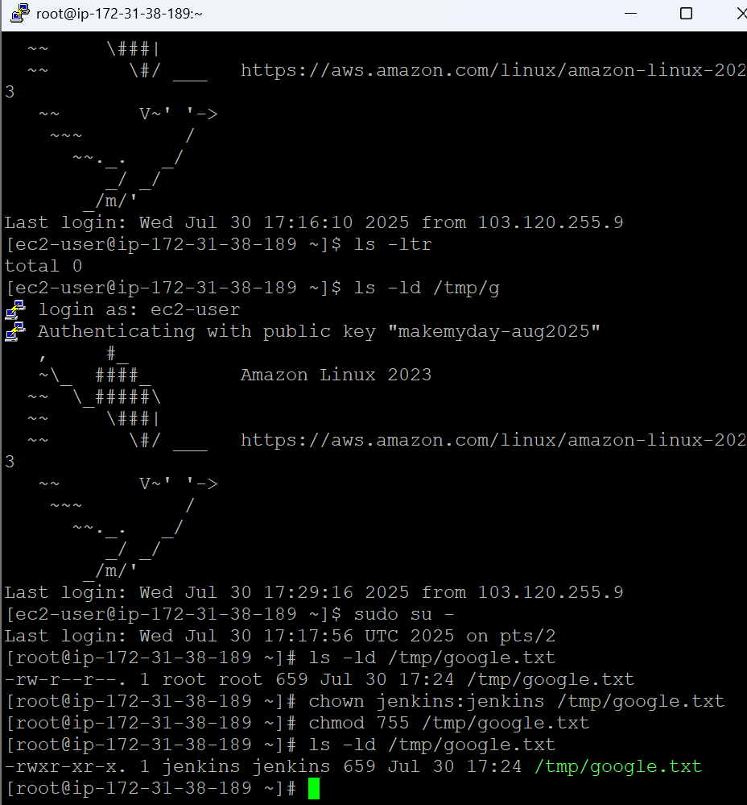

Cron code job example just an example

## 🕒 CRON Format:

lua

CopyEdit

* * * * * command_to_run

| | | | |

| | | | +----- Day of the week (0 - 7) (Sun=0 or 7)

| | | +------- Month (1 - 12)

| | +--------- Day of the month (1 - 31)

| +----------- Hour (0 - 23)

+------------- Minute (0 - 59)

### 🔁 1. ****Run Every Minute****

bash

CopyEdit

* * * * * echo "Runs every minute"

### 🕐 2. ****Run Every Hour****

bash

CopyEdit

0 * * * * echo "Runs every hour at minute 0"

### 📆 3. ****Run Every Day (Once a Day)****

bash

CopyEdit

0 2 * * * echo "Runs every day at 2 AM"

### 📅 4. ****Run Every Month (Once a Month)****

bash

CopyEdit

0 3 1 * * echo "Runs on 1st of every month at 3 AM"

### 📅 5. ****Run Every Week (Once a Week)****

bash

CopyEdit

0 4 * * 0 echo "Runs every Sunday at 4 AM"

Note: 0 means Sunday

### ⚡ Bonus: Run on Specific Time

bash

CopyEdit

30 9 * * 1-5 echo "Runs at 9:30 AM, Monday to Friday"

### From chat gpt I have got below and above example just to understand 🧪 Jenkins Example:

In Jenkins pipeline:

groovy

CopyEdit

pipeline {

triggers {

cron('0 2 * * *') // runs daily at 2 AM

}

stages {

stage('Job') {

steps {

echo 'Scheduled job running...'

}

}

}

}